**CSP 554 – Assignment #13**

Name: Adarsh Mathad Vijayakumar

CWID: A20424847

Email ID: avijayakumar@hawk.iit.edu

Changing to the working directory and creating a db with the name A20424847

Loading the javascript ex3.js

viewing the contents of the ex3.js using the db.unicorns.find()

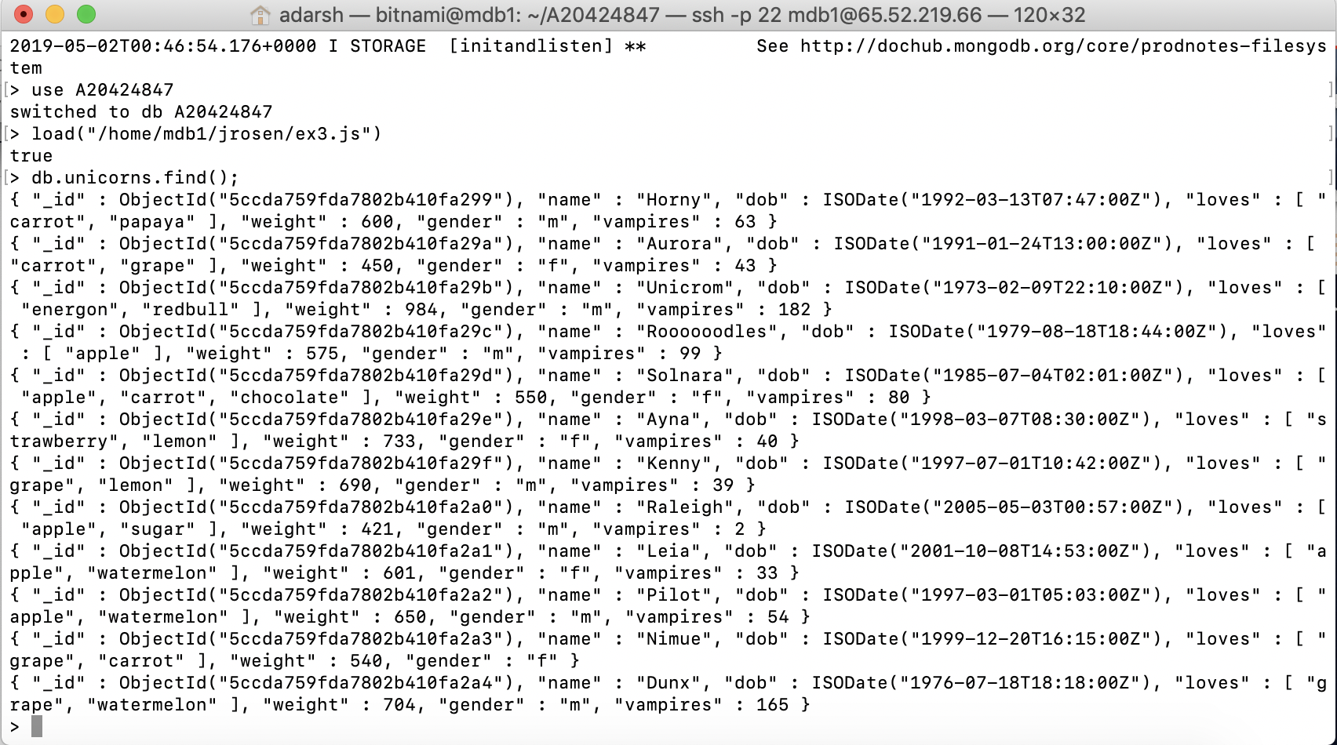

**Exercise 1)**

Write a command that finds all unicorns having weight less than 500 pounds. Include the code you executed and some sample output as the result of this exercise.

**Command:** db.unicorns.find({weight:{$lt:500}})

**Output Screenshot:**

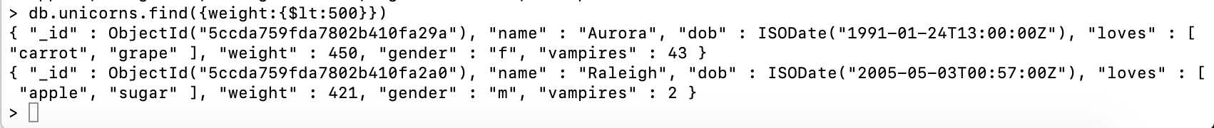

**Exercise 2)**

Write a command that finds all unicorns who love apples. Hint, search for “apple”. Include the code you executed and some sample output as the result of this exercise.

**Command:** db.unicorns.find({loves:”apple”})

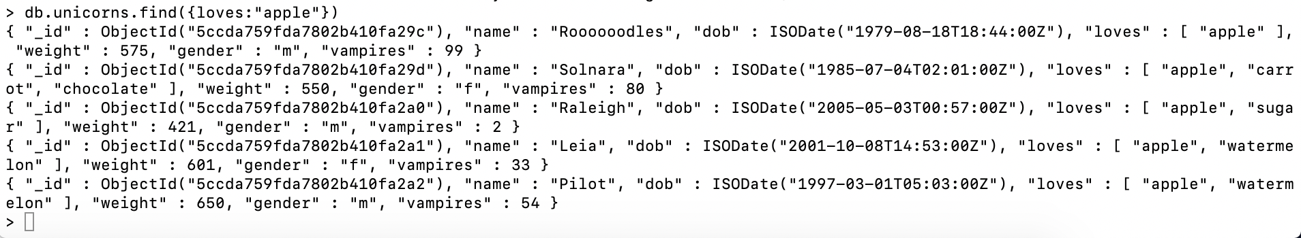

**Exercise 3)**

Write a command that adds a unicorn with the following attributes to the collection. Note dob means “Date of Birth.”

Include the code you executed to insert this unicorn into the collection along with the output of a find command showing it is in the collection.

**Command:** db.unicorns.insertOne({name:”Malini”, dob:”2008-03-11”, loves:[”pears”,”grapes”], weight:450, gender:”F”, vampires:23, horns:1})



**Command:** db.unicorns.find();

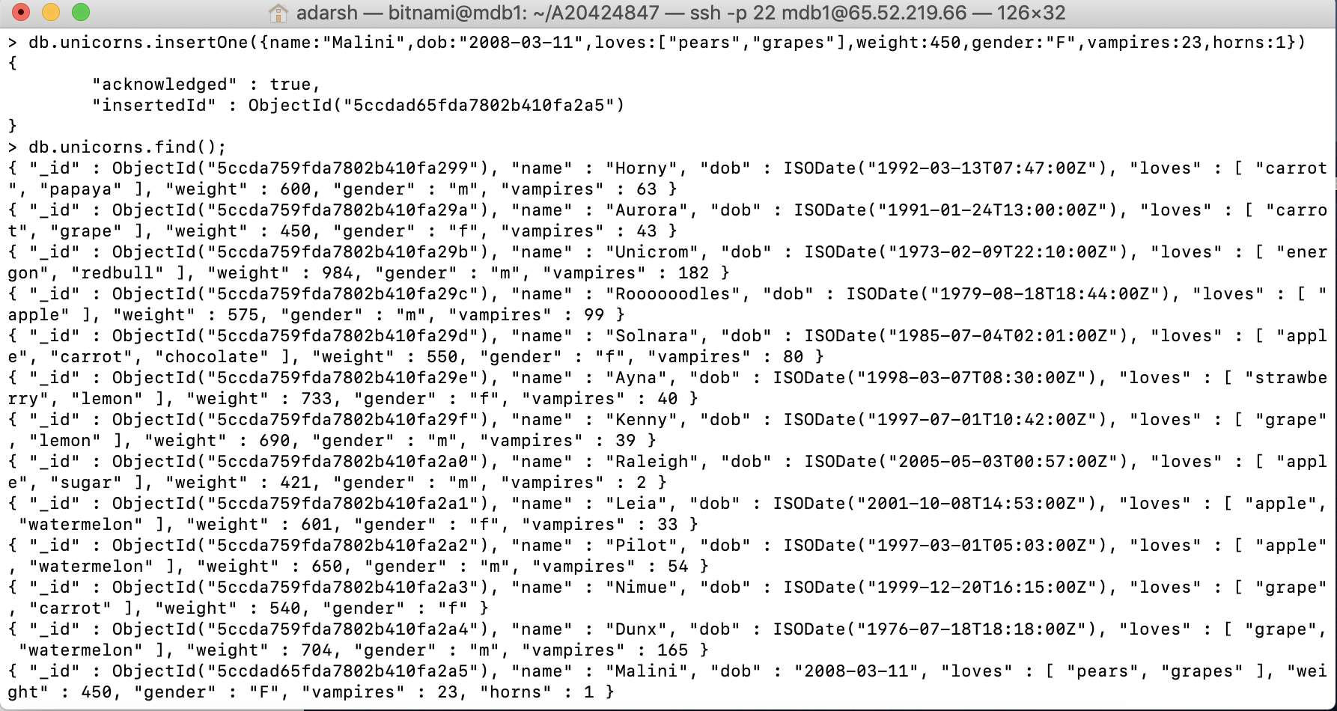

**Exercise 4)**

Write a command that updates the above record to add apricots to the list of things Malini loves. Include the code you executed and some sample output showing the addition.

**Command:** db.unicorns.updateOne({loves:[“pears”,”grapes”]},{$set:{loves:[“pears”,”grapes”,”apricots”]}})



**Command:**

db.unicorns.find(name:”Malini”);

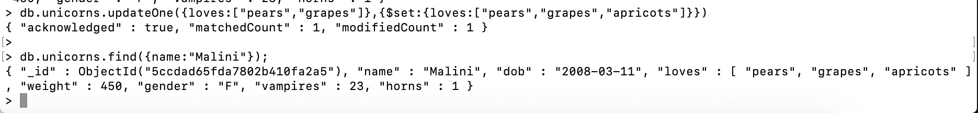

**Exercise 5)**

Write a command that deletes all unicorns with weight more than 600 pounds. Include the code you executed and some sample output as the result of this exercise.

**Command:** db.unicorns.deleteMany({weight:{$gt:600}})

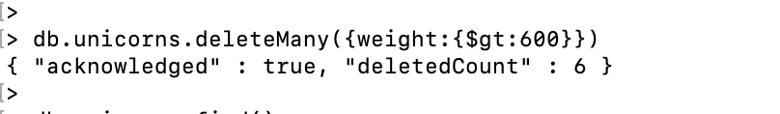

**Command:** db.unicorns.find();

